Eyeconic - Glasses Shop Management System

Use-Case Specification: Remove Contact Lens

Version 1.0

Revision History

|  |  |  |  |
| --- | --- | --- | --- |
| **Date** | **Version** | **Description** | **Author** |
| 05/11/2019 | 1.0 | Start creating use case | Đỗ Nguyễn Hoàng Ân |
|  |  |  |  |
|  |  |  |  |
|  |  |  |  |

Table of Contents

**Remove contact contact lens** **4**

Brief Description 4

**2. Flow of Events** **4**

2.1 Basic Flow 4

2.2 Exception 5

2.2.1 Remove contact contact lens 5

2.2.2 Confirming editing the brand 5

**3. Special Requirements** **5**

**4. Preconditions** **5**

4.1 Admin must be logged in 5

**5. Postconditions** **5**

**6. Extension Points** **5**

Use-Case Specification: Remove contact contact lens

# Remove Contact Lens

## Brief Description

This use case defines the step of removing existing contact contact lens from the database.

contact lens are removed by the admin.

# 2. Flow of Events

## 2.1 Basic Flow

The system administrator selects the contact contact lens data to remove. The administrator deletes the contact contact lens data from the website. The system displays the updated management parameter value and logs the change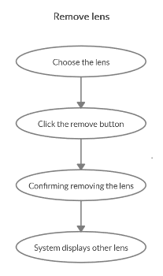

***Basic flow of Removing contact contact lens***

Step 1: Choose the contact contact lens you want to remove

Step 2: Click remove button

A modal view shows up with content “Are you sure want to remove this item?”

and two button “Yes” and “No”

Step 3: Confirming adding the contact contact lens by clicking the “Yes” button.

Step 4: Contact lens are removed from database and no longer appear on the screen.

## 2.2 Exception

### 2.2.1 Remove contact lens

The remove button cannot be clicked or isn’t appeared on the screen

### 2.2.2 Confirming editing the contact lens

The “Yes” button is clicked but the brand are not removed

# 3. Special Requirements

No Special Requirements

# 

# 4. Preconditions

## 4.1 Admin must be logged in

User must already login as the administrator of the website

# 5. Postconditions

All other products can be shown and purchased as normal.

Deleted contact contact lens can not be seen on the screen or database.

# 6. Extension Points

Administrator checks the website and the system to ensure that the contact contact lens is completely removed.